Source ID: 316509599

Source Title: International Journal of Life Sciences Biotechnology and Pharma Research

Agreement URL: <http://www.ijlbpr.com/>

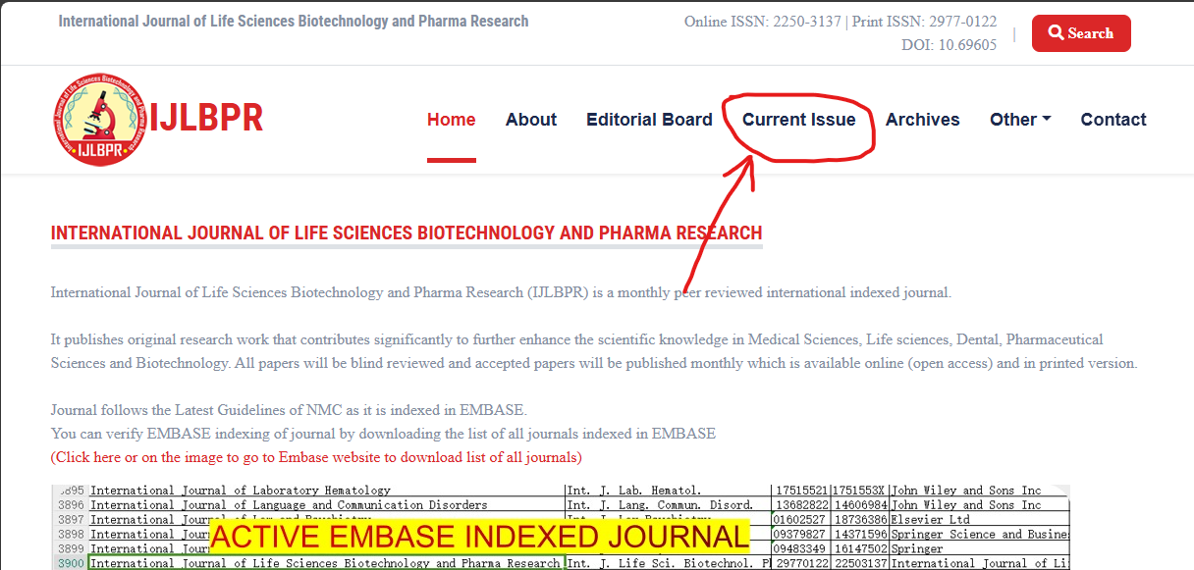

**Click here**

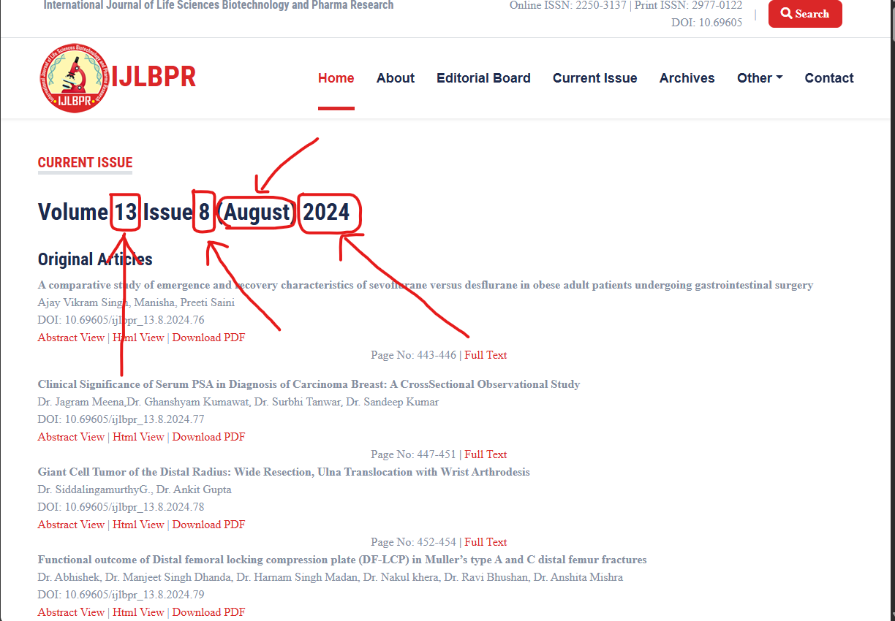

**Year**

**Month**

**Issue**

**Volume**

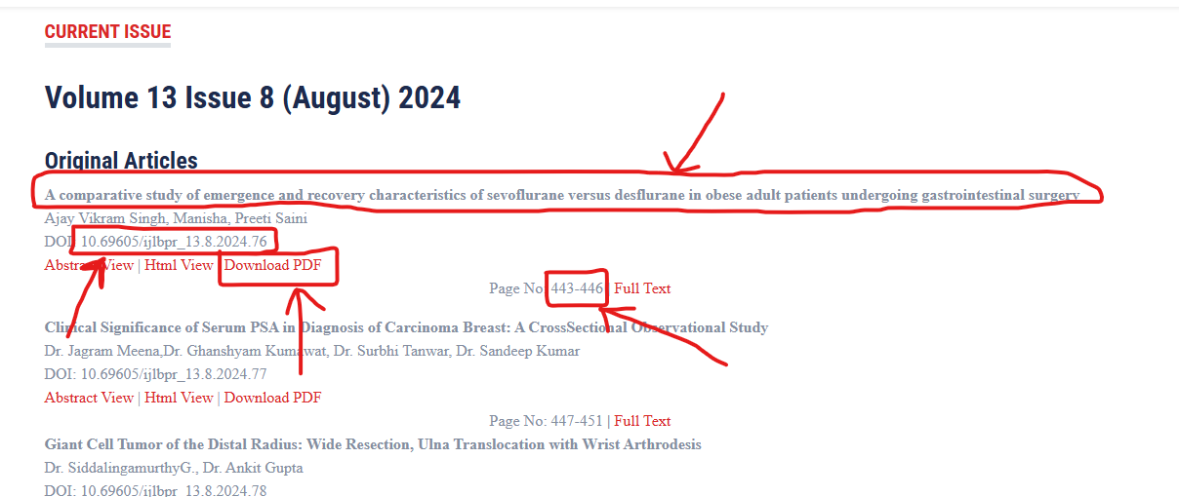

**Page range**

**Click here to Download PDF**

**DOI**

**Title**